**IOT BASED WHEELCHAIR OPERATED BY HEAD MOVEMENT**

MINOR PROJECT-1

Submitted by:

Mayank : 9916103156

Harshit Jaiswal : 9916103218

Mahima Guwalani : 9916103152

Under the Supervision of:

**Dr Neeraj Jain**



DEPARTMENT OF CSE

JAYPEE INSTITUTE OF INFORMATION TECHNOLOGY,

NOIDA

OCTOBER, 2018

**ABSTRACT**

Wheelchairs are used by people who have difficulty in movement of lower body due to any disease, injury or because they’re born differently abled. Due to the advancement in technology, wheelchairs come in different varieties these days. Earlier we knew just about manual ones, but with time, autonomous wheelchairs with advanced seating adaptations, individualized controls and IOT enabled systems are replacing them. These innovations have reduced manual labour work and thus made wheelchairs more comfortable and easy to use. As a matter of fact,all electric wheelchairs are very costly and not everyone can afford it.

Thus, we have found a solution to this problem, by making a cost effective wheelchair which works on head gesture movements,making it easier for paralysed or people without limbs to control it. These wheelchairs will have an inbuilt health sensor which will be connected to the server online, so that anyone having an access to it can know about the person’s well being even when he is not around. Some of the sensors we will be using are : Pulse Sensor, GPRS & GSM Modules. As Internet Of Things, are so trending nowadays so we thought of the solution to the problem of tracing the location as well as the health condition of the person sitting on the wheelchair. We earlier thought of making an Android Application or a Web Application to trace the details but as ChatBots are so trending nowadays and have many perks over normal applications. So we will be implementing a Google Assistant Application.

(i)

**TABLE OF CONTENTS**

1. Cover Page
2. Abstract
3. List of figures
4. Abbreviations
5. Introduction

5.1 About Project

5.2 Motivation

5.3 Objective

5.4 Contribution

6. Background Study

7. Requirement Analysis

7.1 Hardwares

7.2 Softwares

8. Detailed Design

9. Implementation

10. Testing Reports

11. Conclusion of the Project

12. Proposed work plan of remaining period with Gantt chart

13. References

(ii)

**List of figures**

1. FIG 1.1- Pie chart indicating the type of wheelchairs used by people.
2. FIG 1.2- Article from Web Search About Problems Handicapped People Face. Article Link in Reference.
3. FIG 1.3- An Arduino UNO
4. FIG 1.4- Accelerometer Gy-61
5. FIG 1.5- NRF24L01+ Module
6. FIG 1.6- L293D Motor Driven IC
7. FIG 1.7- IC 7809, 7805 Voltage Regulator

(iii)

**ABBREVIATIONS**

* **GSM**- Global Systems for mobile communication.
* **GPRS**- General Packet radio services
* **IOT**- Internet of things

(iv)

**INTRODUCTION**

* **About Project:**

Internet of things(IOT) can be defined as a network of all the physical devices which are electronic or have some kind of software embedded in them and allows communication to between these objects and other internet enabled devices and systems. They allow a better connection of these objects to the physical world. Examples- security systems, cars, home automation etc.We have created an IOT based model of a wheelchair,that would detect the head movements and allowing the wheelchair to move accordingly. We have used Accelerometer Sensor for the Head Movement Recognition and have used Arduino Boards as Microcontrollers and for Data Transmission we have used NRF Modules. We have used Accelerometer Sensor for the Head Movement Recognition and have used Arduino Boards as Microcontrollers and for Data Transmission we have used NRF Modules.

* **Motivation**

As nowadays many cases of people with disability in movement have been found, especially with limb disability so we have thought of a solution to create an IOT based model of a wheelchair, that would detect the head movements and allowing the wheelchair to move accordingly. The person sitting on the wheelchair is prone to having an emergency situation like: fallen from the wheelchair, fainting, shortness of breath, etc. then it will immediately alert the person’s family or well wishers by sending an alert message. Also it would be transferring the data from the wheelchair to the Server online which would be providing information like the location and health condition of the person using the wheelchair anytime, anywhere.

* **Objective**

To make an IOT enabled head movement control wheelchair which has health sensors and a Google assistant bot for checking the health condition and location of the person.

* **Contribution**

With the help of this project we aim to further progress the Make In India slogan that our Honorable Prime Minister gave the country. The wheelchair would not help the disabled but will also empower them. The functioning of the wheelchair is quite easy. One doesn’t have to be technically fluent in order to operate the machine. A person who has basic education can easily maneuver the wheel chair. The wheelchair is the perfect culmination of modern technology and hard work.

1

**BACKGROUND STUDY**

**WHEELCHAIRS:**

WheelChairs are used by people for whom walking is difficult or impossible due to illness, injury or disability. It is either propelled manually or using automated systems. As of the 2011 Census data for India revealed that out of 121 crore people 2.68 crore people are disabled and out of these 2.68 crores 20% of them have disability with movement.

Also nowadays Autonomous WheelChair’s are too costly and not to user friendly when it comes to Help in case of emergency.

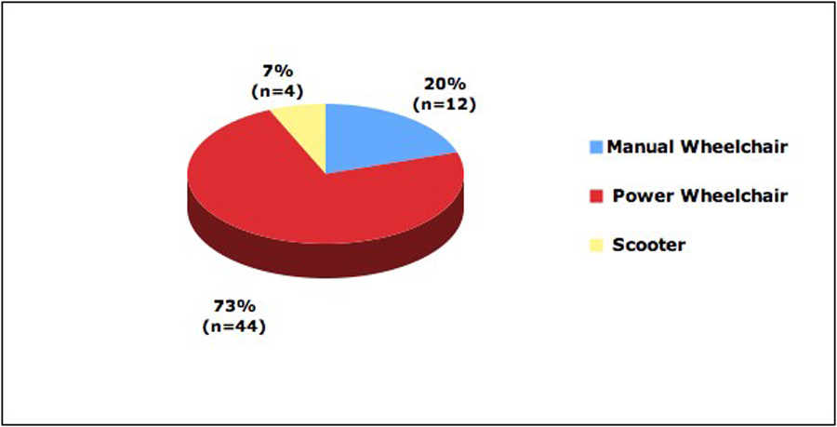

**FIG 1.1 Pie Chart Showing Different Percentage of people using WheelChairs.**



**FIG 1.2 An Article showing the major problems disabled people have to face.**

**ARDUINO :**

Arduino is an open source hardware and software that manufactures microcontrollers that helps in building interactive objects that can help in connecting with the physical world. In other words it is used to convert computer code into physical work. The best thing about arduinos is that it is easy to use and is best for beginners. It supports a variety of operating systems. We are using Arduino UNO Boards.

2

**REQUIREMENT ANALYSIS**

**HARDWARE:**

1. **ARDUINO UNO** - Arduino UNO is an open source microcontroller board that has 14 digital and 6 Analog input output pins . It contains the Microcontroller ATMEGA328P. We are using two Arduino UNO Boards one for the Head-Band and another for the WheelChair.

* Microcontroller: Microchip ATmega328P
* Input Voltage: 7 to 20 Volts
* Digital I/O Pins: 14 (of which 6 provide PWM output)
* Analog Input Pins: 6
* DC Current per I/O Pin: 20 mA
* DC Current for 3.3V Pin: 50 mA
* Flash Memory: 32 KB of which 0.5 KB used by bootloader
* SRAM: 2 KB
* Clock Speed: 16 MHz

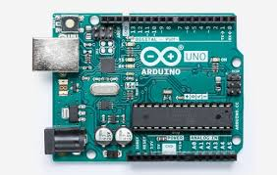

**FIG 1.3 Arduino UNO Board**

1. **ACCELEROMETER Gy-61**: is a three axis accelerometer sensor module based on ADXL335 integrated circuit. The ADXL335 is a triple axis accelerometer with extremely low noise and power consumption. The sensor has a full sensing range of +/-3g. It can measure the static acceleration of gravity in tilt-sensing applications, as well as dynamic acceleration resulting from motion, shock, or vibration.

There is an on-board 3.3V voltage regulator to power the ADXL335 so power provided should be between 3V and 6V DC.

3

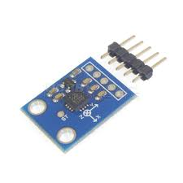

**FIG 1.4 Accelerometer Gy-61**

1. **NRF Modules**: It is used to make a wireless communication between two Arduino boards. It uses the 2.4 GHz band and it can operate with baud rates from 250 kbps up to 2 Mbps. If used in open space and with lower baud rate its range can reach up to 100 meters.

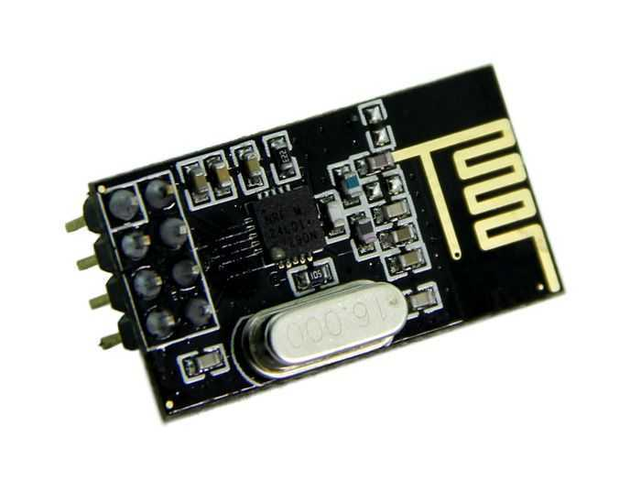

**FIG 1.5 NRF24L01+ Module**

1. **JUMPER WIRES**- they are simple wires having connecting pins at both ends that helps to connect two points in a circuit without the need of soldering.
2. **Batteries**- We are using two rechargeable DC batteries of 12V each.
3. **L293D**: L293D is a dual [H-bridge](http://www.engineersgarage.com/electronic-circuits/h-bridge-motor-control) motor driver integrated circuit (IC). Motor drivers act as current amplifiers since they take a low-current control signal and provide a higher-current signal. This higher current signal is used to drive the motors.

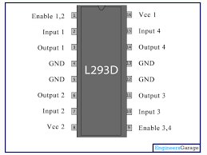

**FIG 1.6 L293D Motor Driven IC**

1. **IC 7809,7805**: Voltage sources in a circuit may have fluctuations resulting in not providing fixed voltage outputs. A voltage regulator IC maintains the output voltage at a constant value. 7805 and 7809 IC,are members of 78xx series of fixed linear voltage regulators used to maintain such fluctuations, is a popular voltage regulator integrated circuit (IC). The xx in 78xx indicates the output voltage it provides. 7805 IC provides +5 volts and 7809 IC provides +9 volts regulated power supply with provisions to add a heat sink.

4

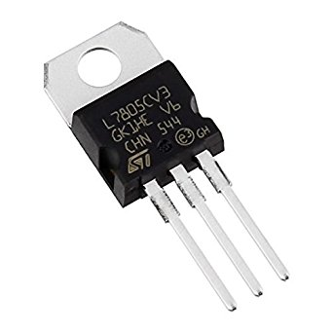

**FIG 1.5 NRF24L01+ Module**

1. **Other Hardware Devices**: Wheels, Chassis, Two High Torque Motor,HeadBand.

**SOFTWARE**:

1. **ARDUINO IDE**- The open-source **Arduino** Software (**IDE**) makes it easy to write code and upload it to the board. It runs on Windows, Mac OS X, and Linux. The environment is written in Java and based on Processing and other open-source software. This software can be used with any **Arduino** board.
2. **SUBLIME TEXT-3**:Sublime Text is a proprietary cross-platform source code editor with a Python application programming interface. It natively supports many programming languages and markup languages, and functions can be added by users with plugins, typically community-built and maintained under free-software licenses.

5

**DETAILED DESIGN**

In Detailed Design, we have made the circuit diagram of both the Headband as well as the WheelChair. We implemented the design of Headband over HeadPhones and WheelChair over the Chassis.

* HeadBand Circuit Diagram:

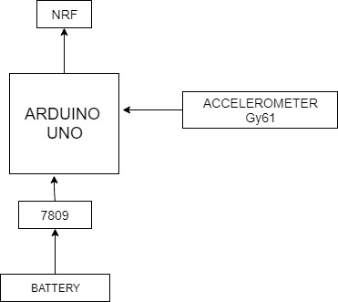

**Fig. 1.8 Circuit Diagram of HeadBand (arrows show direction of flow of data or current)**

In this Circuit, we have connected Arduino UNO with Accelerometer Gy-61, NRF Module,7809(Voltage Regulator IC) and a battery with the help of Jumper Wire and a Switch.

* **WheelChair Circuit Diagram**:

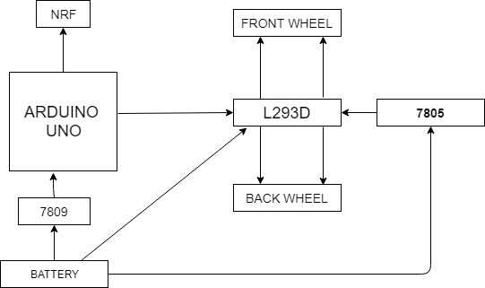

**Fig 1.9 WheelChair Circuit Diagram**

In this circuit, we have connected Arduino UNO with NRF to collect data and then L293D to transfer voltage for running the motors. 7805 & 7809 are used for voltage regulation.

6

**IMPLEMENTATION**

We have divided the project in 3 parts: Making Head Movement Controlled WheelChair IOT enabled, secondly adding health sensors as well as GPRS and GSM Modules, and last part is to make the google assistant app and sending data to servers. Till now we have done the 1st part and read about 2nd and 3rd part. So implementation of first part :

* **Remote Controlled WheelChair**: First of all Arduino UNO is connected to Battery(12V) via IC 7809 as Arduino works on Voltage of 9V so we converted it to 9V via voltage regulator .Then the connection between Arduino and L293D(Motor Driven IC) will be done and also L293D is connected to Battery directly to supply power to Motors and via 7805 as IC 7805 is required to convert the voltage from 12V to 5V required for activation of L293D.

NRF Module is added to the Arduino via the ICSP Headers for Data Transmission. We setup the whole thing over a metal Chassis and wheels.

* **Head Movement Band**: We have used Accelerometer Gy-61 to detect the movement of Head and which will then help in motion of WheelChair. For Accelerometer power supply of 3.3 V is provided via the Arduino. The analog output from the sensor is taken by two pins coordinates x and y and send to Arduino where we mapped the values between -90 to 90 and then for particular motion we assigned a value like 1 for forward, 2 for left, 3 for right and 4 for stop. This value is send to the Arduino of WheelChair through NRF Modules connected to both the Arduino.
* The wheelchair is simulated using a plastic and metal housing with 2 DC 12V motors and one 12V lithium ion battery.
* The simulated wheelchair/actual wheelchair is/will fully self sufficient with the except of the battery being recharged occasionally.
* A on-the-ear style headset was used as the base for the headgear instead of a custom one due to budget and practical limitations.
* The headset mechanism is powered through a 12V lithium ion battery not unlike the simulated wheelchair.

7

**TESTING REPORTS**

While doing the testing of the WheelChair, we have tested both the outputs of the WheelChair as well as headband over the Arduino IDE. COM 6 is the output of the Serial Monitor of the WheelChair and COM 5 is the output window of the Serial Monitor of HeadBand. In COM 5 the two values are analog values of the x and y pin of the accelerometer.

1. **Head tilt Forward 2. Head tilt towards Right**

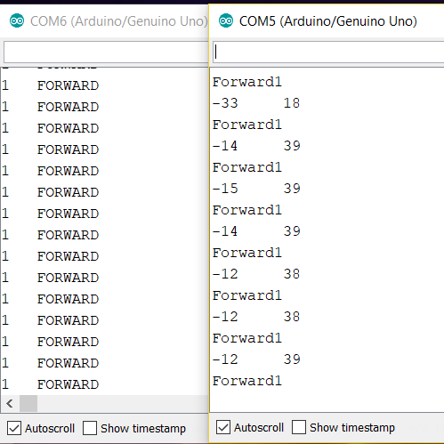 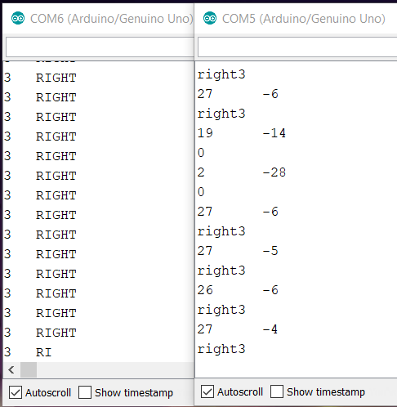

**3. Head tilt backwards to STOP 4. Head tilt towards LEFT**

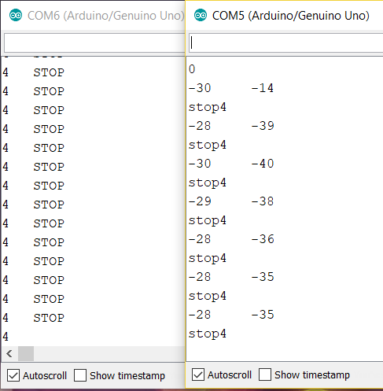 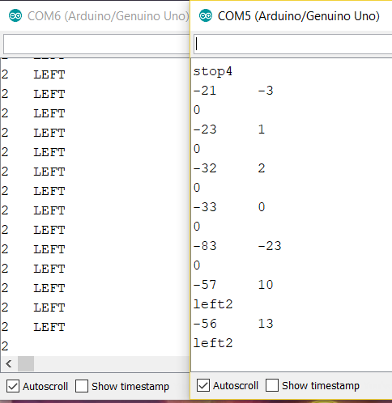

8

**CONCLUSION OF THE PROJECT**

The Autonomous WheelChair is a great machine for disabled people. Those who have lost the motor nerves in their spine or feet often face the difficulty to walk. Our machine is designed keeping those people in mind. Old people also often face problem in walking. Weak knees often make them bed-ridden. But our wheelchair will surely allow people to walk. One of the best things about our custom electric wheelchair is that it is built at a fraction of cost of the ones available in the market. So even the poor people can afford our Autonomous Wheelchair. It is built from local parts that were either bought off the internet or were purchased at the local electrical shop.

Also, the handling of the machine is also quite easy. So if a person isn’t very tech-savvy, then also he/she can operate the machine. The Smart Wheelchair is a boon for disabled people. It is quite cheap and can easily be controlled. It is small in size and takes less space. As a result, this product can be a hit in the market if marketed correctly.

The wheelchair can be fitted with small sensors to make it auto-movable. The smart wheelchair can also be coupled with machine learning, to make sure that the daily path that the user takes is automatically stored. We have also planned to install GSM Module so in case of emergency a particular Head Movement will alert the well wishers . Not only this, We are also going to use Speech to Text Library of Arduino to Control the Wheel Chair by Voice. It will not be less than a gadget in future.

9

**Proposed work plan of remaining period with Gantt chart**

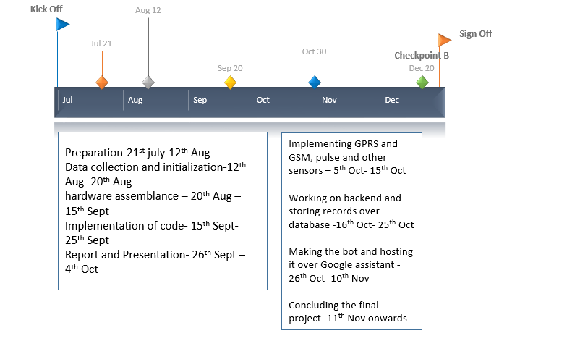

10

**REFERENCES:**

1. The true cost of being disabled goes far beyond just the physical: James Moore[Online]. Available:<https://www.independent.co.uk/voices/comment/the-true-cost-of-being-disabled-goes-far-beyond-just-the-physical-9628374.html> .[Accessed 25-08-2018]
2. Srishti,Prateeksha Jain, Shalu, Swati Singh, “Design and Development of Smart Wheelchair using Voice Recognition and Head Gesture Control System”, International Journal of Advanced Research in Electrical, Electronics and Instrumentation Engineering,Vol. 4,Issue 5, May 2015
3. R. C. Simpson, E. F. LoPresti, R. A. Cooper, "How many people would benefit from a smart wheelchair?", *Journal of Rehabilitation Research and Development*, vol. 45, no. 1, pp. 53-71, 2008.
4. Richard C. Simpson, "The Smart Wheelchair Component System", *Journal of Rehabilitation Research & Development*, vol. 41, no. 3B, pp. 429-442, May/June 2004.
5. Ding Dan, Rory A. Cooper, "Electric powered wheelchairs", *IEEE Control Systems Magazine*, pp. 22-34, 2006.
6. Klabi I., Masmoudi M.S., Masmoudi M., "Advanced user interfaces for intelligent wheelchair system", 1st IEEE Conference on Advanced Technologies for Signal and Image Processing, 2014, pp.130-136, Tunisia
7. Itead,[Online].Available:<https://www.itead.cc/nrf24l01-module.html>.[Accessed 15-09-2018]
8. Github[Online].Available:<https://github.com/Elsarmi/Accelerometer-GY-61>. [Accessed 10-09-2018]

11

**PRESENTATION**

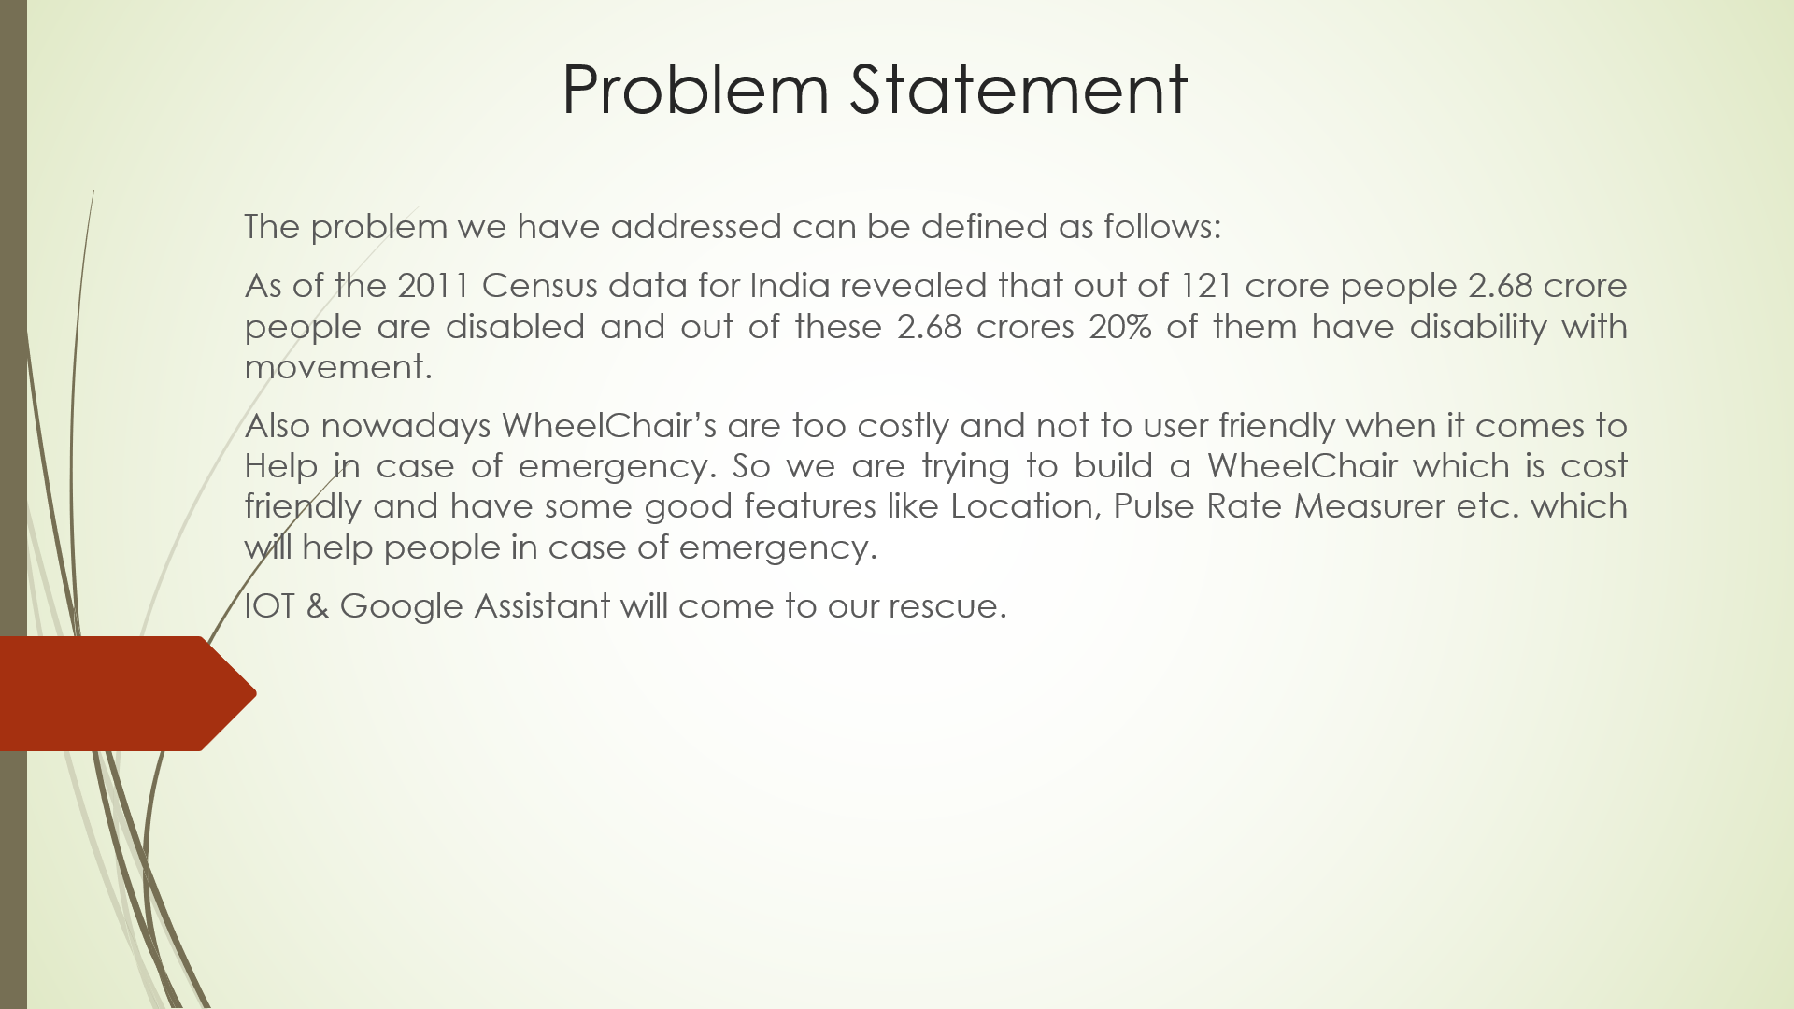

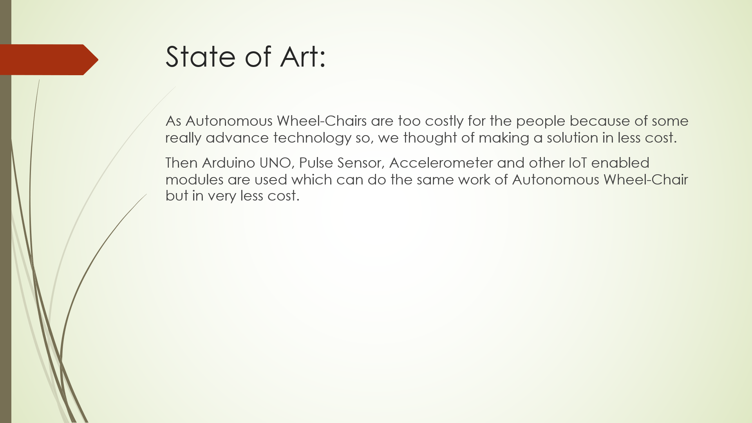

12

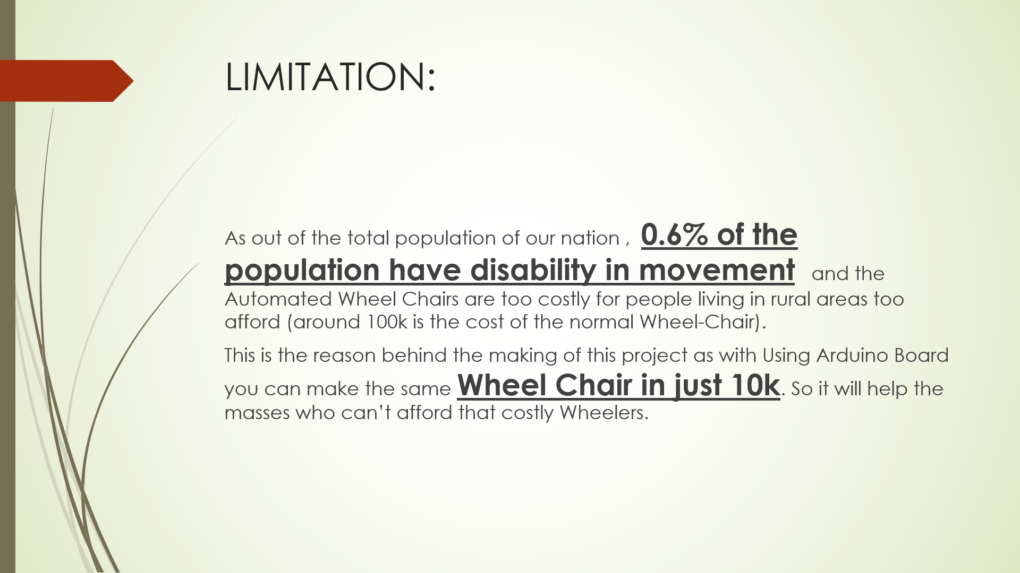

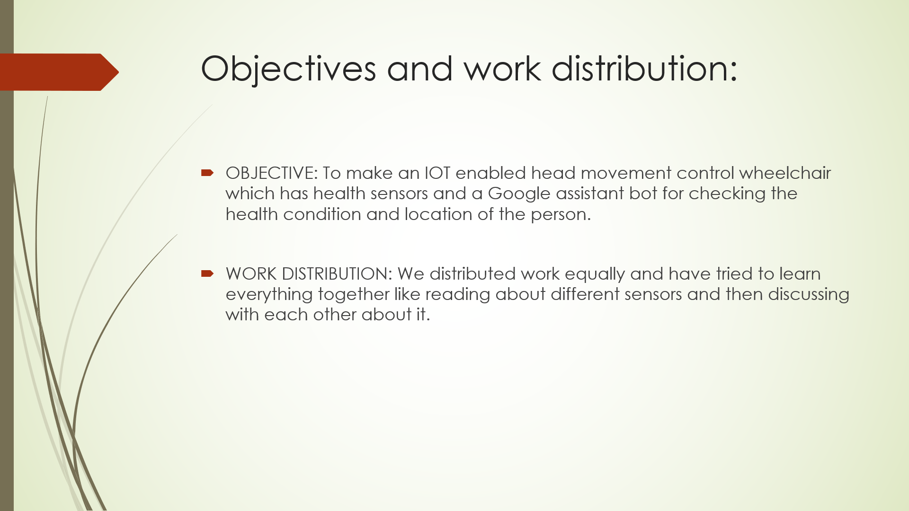

13

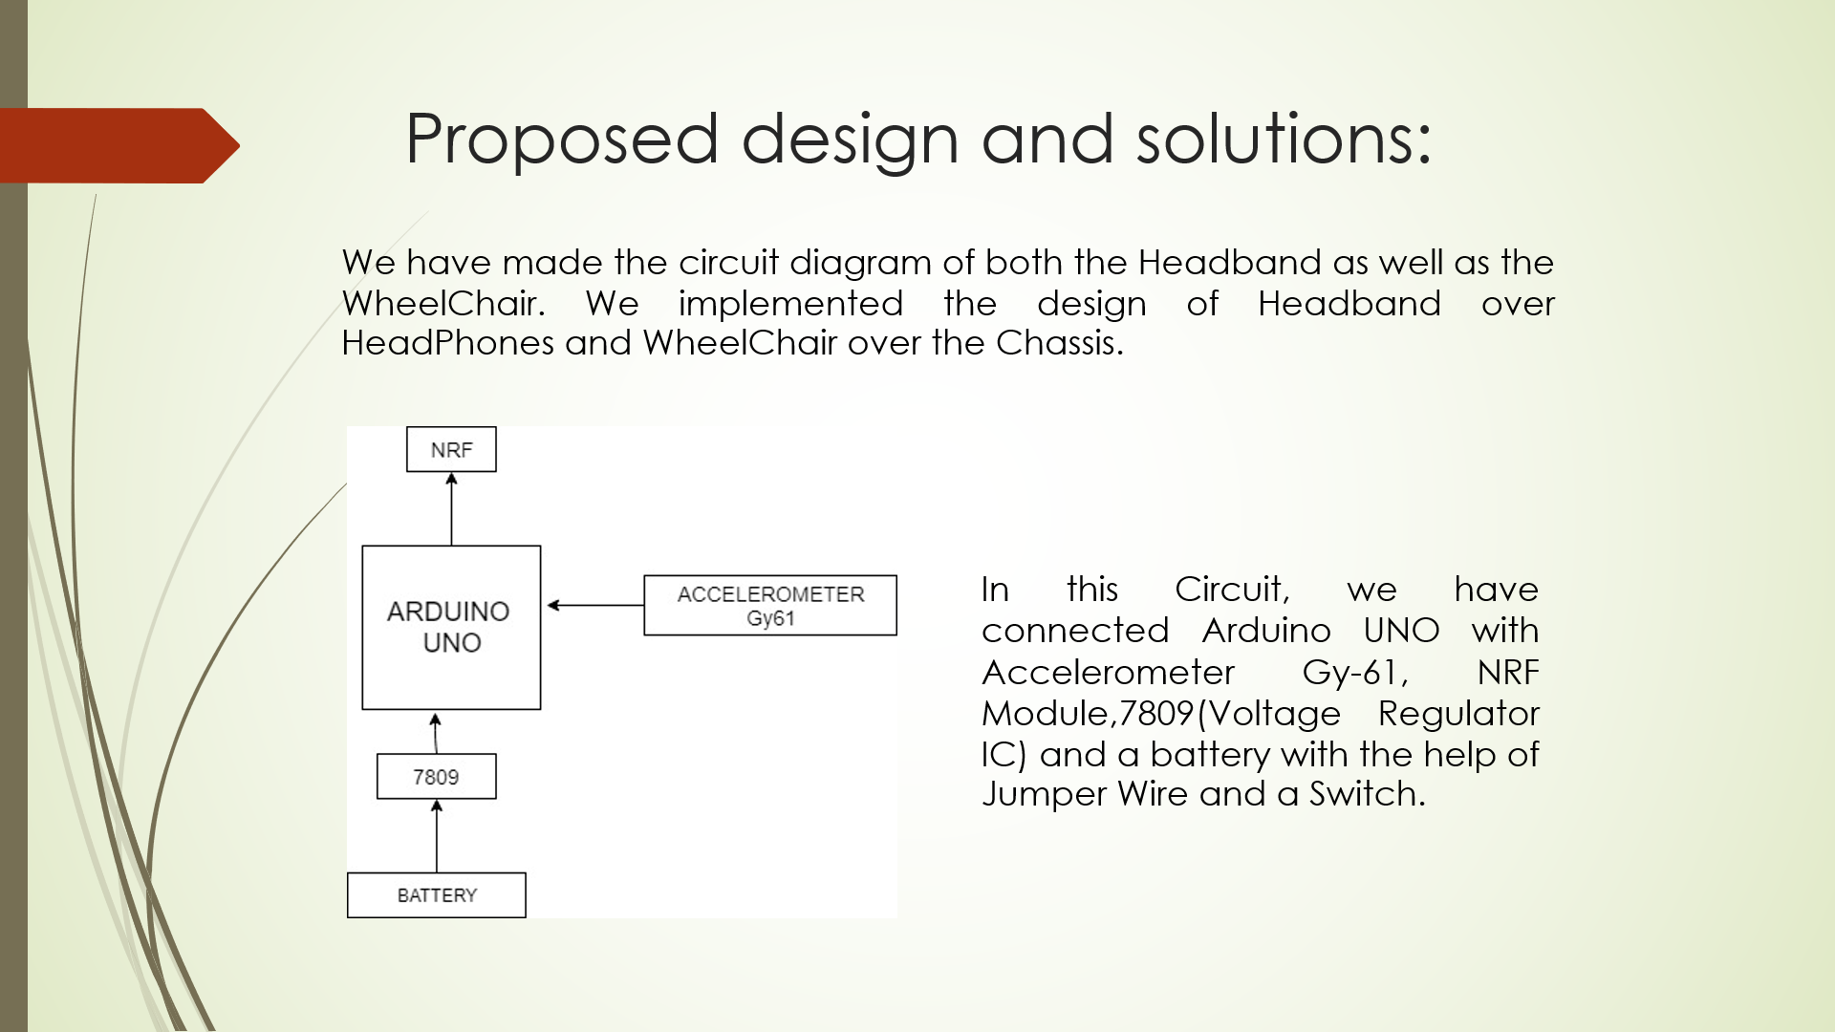

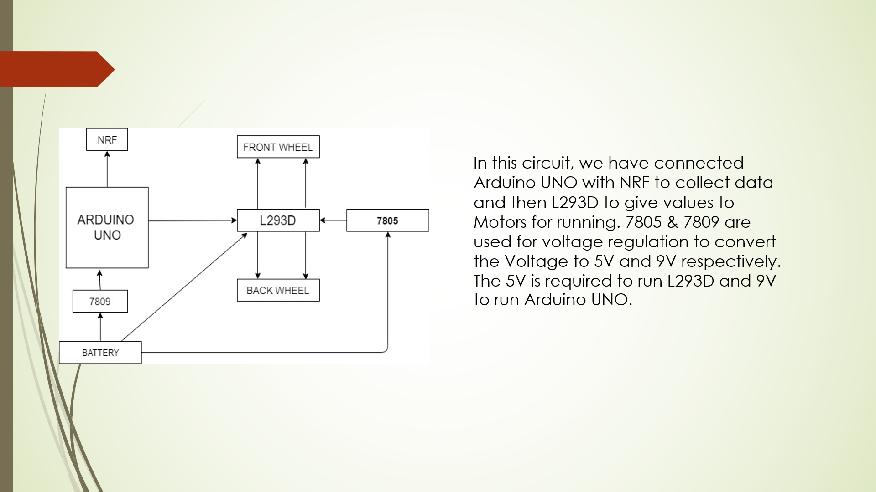

14

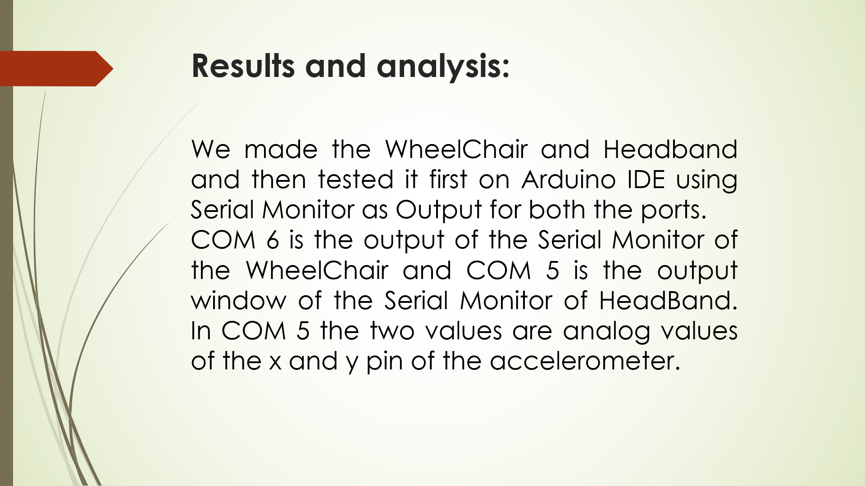

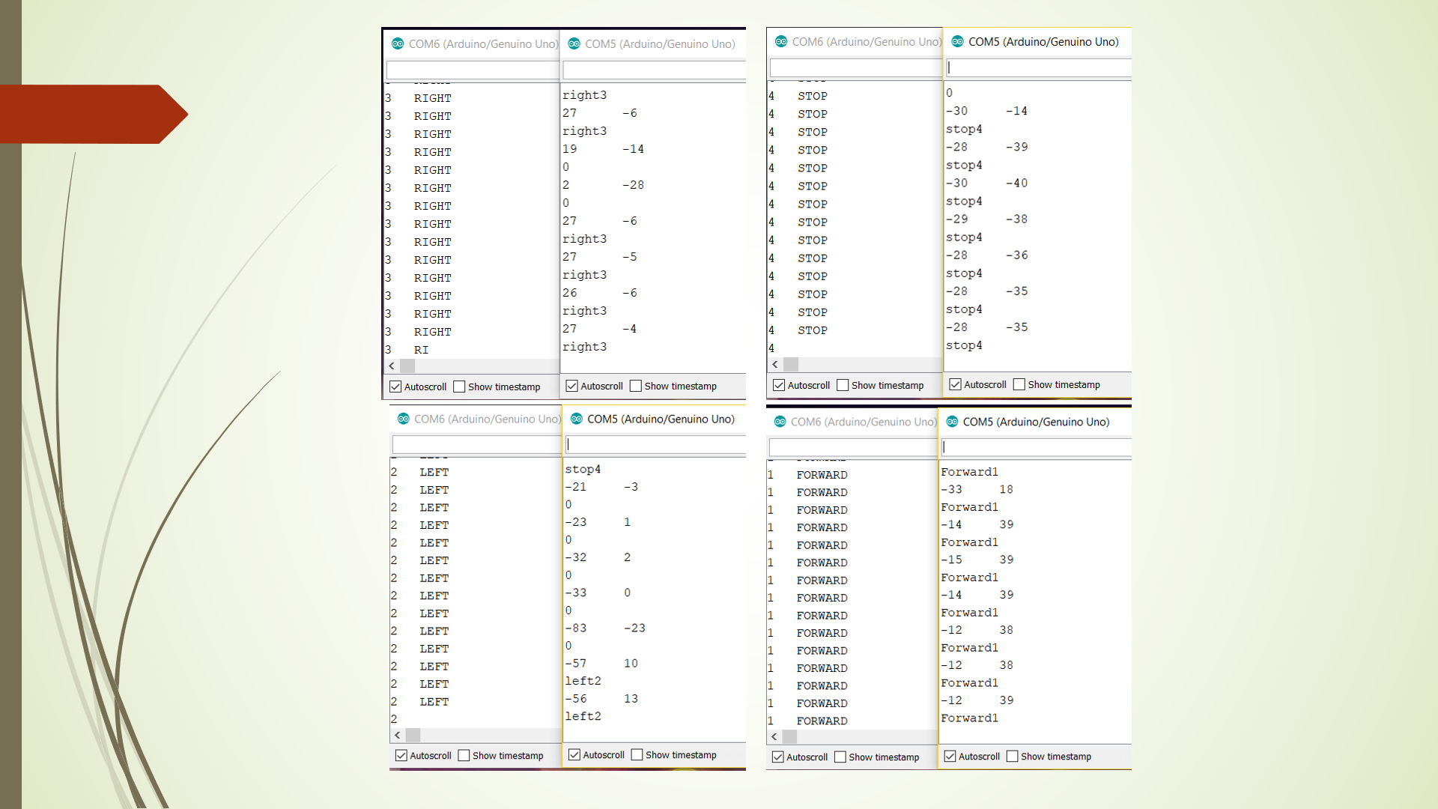

15

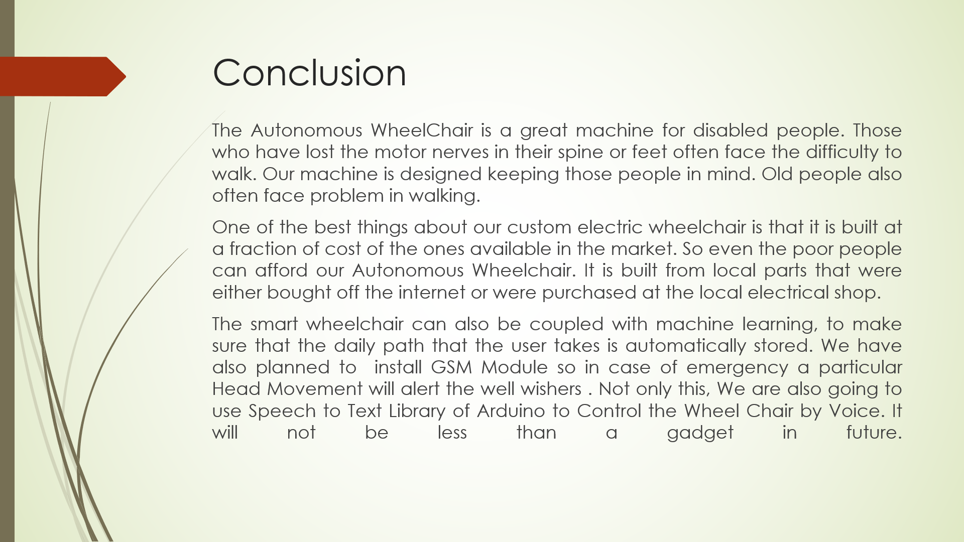



16